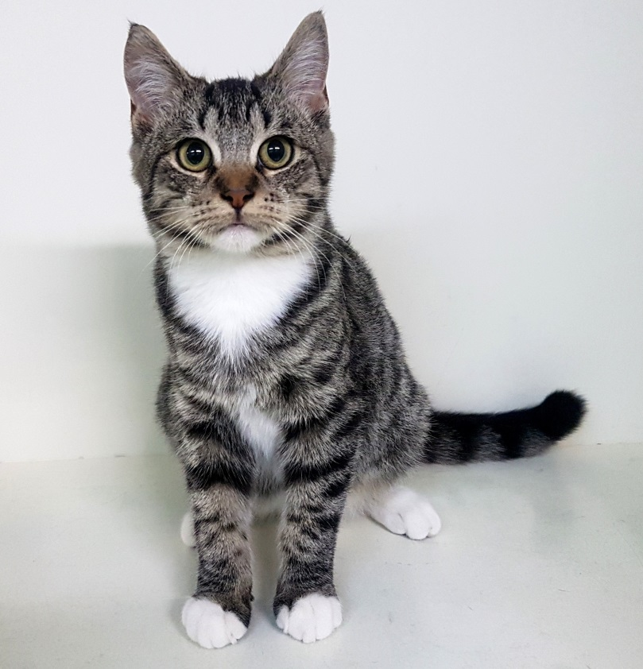 | Name: Socks  Age: 15 weeks  Gender: Male  Personality:  - Sweet and gentle  - Affectionate nature  - Loves head rubs  - Always up for a snuggle  - Would thrive with a quiet and gentle family


